

Project Report
On
“Exploratory Data Analysis on the Financial Sales Insights”

Submitted by
Haimik Solanki

Under The Guidance of
Chintan Patel

Affiliated with
Fly The Nest Institute

Project Report

Contents:
- Problem Statement & Objectives………………………………………………………………………………………… 5
- Executive Summary
- Key Insights
- Problem Statement
- Objectives
- Introduction……………………………………………………………………………………………………………………….. 8
- About the Dataset
- Importance of Financial Data Analysis
- EDA Pipeline Overview
- Data Loading & Preparation……………………………………………………………………………………………….. 12
- Import Necessary Libraries
- Load Data in Jupyter Notebook
- Exploratory Data Analysis (EDA)………………………………………………………………………………………… 13
- Overview of Data (Columns, Data Types, Summary Statistics)
- Handling Missing Values
- Converting Data Types (Date, Currency Formatting)
- Data Visualization & Insights……………………………………………………………………………………
- Unique Segments are in The Dataset…………………………………………………………................... 15
- The most common countries represented in the dataset……………………………………………… 16
- The different product types …………………………………………………………………………………………. 17
- The total revenue, Total cost & Total profit across all transactions……………………………….. 18
- Profit margins vary across different products……………………………………………………………….. 19
- Which segment generates the highest revenue and profit…………………………………………… 20
- Discounts impact profitability………………………………………………………………………………………. 22
- Trend of sales over time………………………………………………………………………………………………. 24
- Seasonal trends in sales and profits…………………………………………………………………………….. 25
- Month had the highest and lowest sales…………………………………………………………………….. 27
- Different years compare in terms of revenue and profit……………………………………………… 29
- Which country has the highest sales and profits…………………………………………………………. 31
- Sales and profits vary by region………………………………………………………………………………….. 33
- Which product category is the most profitable by region…………………………………………… 35
- Are there certain products that perform better in specific countries?........................... 37
- Average sale price per product…………………………………………………………………………………… 39
- Different discount bands impact sales……………………………………………………………………….. 41
- Correlation between discounts and units sold……………………………………………………………. 43
- Average cost of goods sold (COGS) per product…………………………………………………………. 45
- Cost-to-sales vary across segments……………………………………………………………………………. 47
- Business Insights & Recommendations………………………………………………………………….. 49
- Key Sales & Profitability Insights
- Cost Optimization Strategies
- Suggestions for Improving Revenue
- Customer Retention & Growth Strategies
7️ Summary & Conclusion……………………………………………………………………………………………………. 54
- Final Key Takeaways
- Future Scope of Analysis
8️ GitHub Link & References………………………………………………………………………………………………… 56

Executive Summary
This Exploratory Data Analysis (EDA) project investigates financial sales data to uncover trends, performance metrics, and profitability patterns that can inform business decisions. Using Python libraries such as Pandas, Seaborn, and Matplotlib, the dataset was cleaned, transformed, and visualized to extract key insights.
The analysis revealed that:
- Autumn is the most profitable season, with October being the peak month for sales.
- Government and Small Business segments generate the highest revenue and profit, while the Enterprise segment shows poor cost-efficiency.
- The Paseo product category is the top performer in terms of profit across all regions.
- North America leads in sales, but France achieves the highest profit margins.
- Discounts negatively impact profit margins, especially at higher levels.
- A medium discount strategy offers the best balance between volume and profitability.
These insights support strategic recommendations like focusing on high-margin products, optimizing discounts, improving cost efficiency in specific customer segments, and leveraging seasonal trends for targeted marketing. Overall, the EDA provides a data-driven foundation for enhancing financial performance and growth planning.

Key Insights (Point Form)
🔹 Seasonal Sales Trends
• October is the peak sales month; Autumn season brings the highest revenue and profit.
• Rainy and Dry seasons show the weakest performance, requiring strategic attention.
🔹 Product Performance
• Paseo is the most profitable product category across all regions.
• Carretera and Montana underperform in both sales and profit — candidates for repositioning or cost control.
• Velo performs best in France and Germany, indicating regional product preferences.
🔹 Customer Segment Insights
• Government and Small Business segments contribute the most to revenue and profit.
• Enterprise segment has the highest cost-to-sales ratio, indicating poor profitability.
• Channel Partners, though small in revenue, yield high profitability.
🔹 Geographical Insights
• USA leads in total sales, but France leads in profit margins.
• North America accounts for ~60% of total sales — primary market.
• Europe has growth potential due to higher per-unit profitability.
🔹 Discount Impact
• High discounts reduce profit margins significantly — negative correlation.
• Medium discount bands deliver highest total sales — an optimal point.
• Zero discount performs worst in terms of sales volume.
🔹 Sales Over Time
• Overall sales increased ~3.5× from January 2013 to January 2014.
• Strong upward sales trend suggests successful expansion or strategies during 2013.
🔹 Customer Behavior & Orders
• Higher discounts lead to more units sold, but not necessarily higher profits.
• Most profitable transactions occur at low or no discount levels.
🔹 Cost Structure Insights
• VTT and Amarilla have highest average COGS — pricing must protect margins.
• Carretera has lowest COGS — opportunity for high-volume sales.

Problem Statement:
In today’s competitive business environment, analyzing financial sales data is crucial for understanding revenue trends, identifying profitable products, and optimizing business strategies. This project focuses on conducting Exploratory Data Analysis (EDA) on financial sales data to uncover key insights about sales performance, customer purchasing behavior, and profitability metrics.
The dataset consists of raw sales records and a cleaned version, which includes details such as product categories, sales revenue, discounts, profit margins, and seasonal trends. The primary challenges include:
- Cleaning and transforming financial data for accurate analysis.
- Identifying sales trends over time (monthly/yearly) and across different regions.
- Understanding the impact of discounts on revenue and profitability.
- Analyzing customer purchasing patterns to optimize future sales strategies.
By performing data visualization and in-depth analysis, this project aims to help businesses make data-driven decisions, improve sales forecasting, and enhance overall financial performance.

Objectives:
This Exploratory Data Analysis (EDA) project aims to analyze financial sales data to extract meaningful insights that can help businesses optimize their revenue and profitability. The key objectives of this project are:
1️ Data Cleaning & Preparation
- Convert raw sales data into a structured and analyzable format.
- Handle missing values and ensure data consistency.
- Convert financial values (currency, discounts, profits) into proper numerical formats.
2️ Sales & Revenue Analysis
- Identify overall sales trends across different time periods (monthly, yearly).
- Analyze sales performance by country, region, and department.
- Evaluate the impact of price fluctuations and discounts on sales.
3️ Profitability & Cost Analysis
- Determine the most profitable products and departments.
- Analyze the cost-to-profit ratio and identify areas for improvement.
- Measure the effect of discounts on overall profit margins.
4️ Customer & Order Analysis
- Identify top-purchased products and customer buying patterns.
- Understand seasonal variations in sales and demand.
- Analyze average order size and frequency of purchases.
5️ Data Visualization & Insights
- Use visual tools like Matplotlib & Seaborn to create meaningful charts.
- Represent financial trends through line charts, bar graphs, and heatmaps.
- Provide interactive dashboards for easy interpretation.
6️ Strategic Business Recommendations
- Suggest strategies for increasing sales and profitability.
- Identify potential cost-cutting measures without affecting revenue.
- Offer insights for improving customer retention and sales forecasting.
By achieving these objectives, the project will help businesses make data-driven decisions and optimize financial performance effectively.

Introduction:
About the Dataset
The dataset used in this project is a financial sales dataset, which contains detailed records of product sales across different regions, customer segments, and time periods. It provides valuable insights into how sales, discounts, and profitability interact in a business environment.
The data comes in two formats:
1️ Raw Data – This is the original dataset, which may contain missing values, inconsistent formats, and unstructured financial data (e.g., currency symbols, commas, and negative values in parentheses).
2️ Clean Data – This version has been processed and formatted correctly, making it ready for analysis.
What’s Inside the Dataset?
The dataset includes key financial and sales-related columns, such as:
Product Information – Names, categories, and departments of the sold products.
Sales Metrics – Number of units sold, sale price, gross sales, and net sales.
Discounts & Pricing – Discounts applied on products and their effect on revenue.
Profitability Data – Cost of goods sold (COGS), net profit, and profit margins.
Time-based Trends – Sales recorded over different months and seasons.
Geographical Insights – Sales performance across different countries and regions.
Why is This Dataset Important?
This dataset is valuable because it helps businesses understand their financial health by revealing patterns in revenue, profit, and customer purchasing behavior. It allows us to answer important questions like:
- Which products generate the highest revenue?
- How do discounts affect overall profitability?
- Are there seasonal trends in customer demand?
- Which regions or customer segments contribute the most to sales?
By exploring this data, we can uncover trends that help businesses make better financial decisions, optimize pricing strategies, and improve overall sales performance.

Importance of Financial Data Analysis
In today's fast-paced business world, financial data analysis isn't just about crunching numbers—it’s about understanding the story behind those numbers and using that knowledge to make smarter decisions. Every business, big or small, relies on financial data to track its performance, identify trends, and plan for the future.

Here’s why financial data analysis is so important:
1️ Helps Businesses Make Data-Driven Decisions
Gone are the days when companies made decisions based on intuition alone. With proper analysis, businesses can see which products are selling well, which ones are underperforming, and where they can cut costs without hurting revenue. This leads to more profitable and efficient decision-making.
2️ Identifies Sales & Revenue Trends
By analyzing monthly and yearly sales data, businesses can understand seasonal trends, customer demand, and market shifts. For example, if a company sees that certain products sell more during the holiday season, they can adjust their inventory and marketing strategies accordingly.
3️ Optimizes Pricing & Discounts
Pricing is a delicate balance—set it too high, and customers may not buy; set it too low, and profits shrink. Financial data analysis helps businesses understand how discounts affect sales and profits. It ensures that promotions are designed in a way that boosts revenue without harming profitability.
4️ Improves Profitability & Cost Management
Not all products contribute equally to profits. Through financial analysis, businesses can identify their most profitable products and focus on them. It also helps spot unnecessary expenses and reduce operational costs while maintaining efficiency.
5️ Understands Customer Buying Behavior
Who are the most valuable customers? What products do they buy most often? How frequently do they make purchases? These insights help companies create better marketing campaigns, improve customer retention, and personalize offers to maximize sales.
6️ Enhances Forecasting & Future Planning
A business that understands its financial data can predict future sales trends, anticipate market changes, and prepare for uncertainties. This allows companies to be proactive rather than reactive, ensuring long-term stability and growth.

EDA Pipeline Overview
Exploratory Data Analysis (EDA) is the backbone of any data-driven project. It helps us understand the dataset, identify patterns, and prepare data for deeper analysis. In this project, we follow a structured EDA pipeline to ensure a systematic approach to analyzing financial sales data.

Step 1: Data Collection & Loading
What we do?
- Import the necessary libraries (Pandas, NumPy, Matplotlib, Seaborn).
- Load the raw financial sales dataset into a Pandas DataFrame.
Why it matters?
- Ensures we have the right dataset to work with before proceeding.
- Helps us verify that the data is successfully loaded and readable.

Step 2: Data Understanding & Cleaning
What we do?
- Check for missing values and handle them appropriately.
- Convert financial figures (like sales and profit) into numeric formats (removing $, ,, and handling negative values).
- Ensure correct data types (e.g., converting date columns to datetime format).
Why it matters?
- Dirty or inconsistent data can lead to wrong conclusions.
- Cleaning ensures that analysis and visualizations are accurate.

Step 3: Exploratory Data Analysis (EDA)
What we do?
- Get an overview of the dataset (.info(), .describe()).
- Identify key trends in sales, profit, and discounts.
- Analyze customer buying behavior and regional sales performance.
Why it matters?
- Helps uncover insights that may not be visible at first glance.
- Allows businesses to understand revenue trends, customer segments, and profitability drivers.
Step 4: Data Visualization & Insights
What we do?
- Create charts and graphs using Matplotlib & Seaborn to visualize trends.
- Identify top-selling products, seasonal sales trends, and the impact of discounts.
- Perform correlation analysis to understand how different factors (e.g., pricing, discounts, and sales) are related.

Why it matters?
- Makes complex data easier to understand.
- Helps in identifying patterns, anomalies, and business opportunities.

Step 5: Business Insights & Recommendations
What we do?
- Summarize key findings from the analysis.
- Provide actionable recommendations for improving sales and profitability.
- Suggest strategies for cost-cutting, customer retention, and pricing optimization.
Why does it matters?
- Converts raw data into real business value.
- Helps stakeholders make data-driven decisions to boost growth.

Data Loading & Preparation
Import Necessary Libraries
Import Necessary Libraries
Before diving into our financial sales analysis, we need to set up our Python environment with the right tools. Just like a chef needs the right ingredients before cooking, we need to import the necessary libraries to handle data efficiently.
Here’s a quick breakdown of the essential libraries we’ll be using:
- Pandas – The go-to library for handling structured data. It helps us read, clean, and manipulate our dataset effortlessly.
- NumPy – Provides powerful mathematical functions and efficient handling of numerical data.
- Matplotlib & Seaborn – These two libraries help us visualize our data with beautiful charts and graphs, making it easier to spot trends and patterns.
- Datetime – Since we’re dealing with sales data over time, this library will help us work with dates and timestamps.
With these libraries in place, we’re now ready to start exploring our financial sales data!

Load Data in Jupyter Notebook
Now that we’ve imported the necessary libraries, it’s time to bring our data into the notebook so we can start exploring it. Loading the dataset is the first real step in our analysis—think of it like opening the file cabinet before diving into reports.
# Load the financial data
df = pd.read_csv("Financials.csv")

Exploratory Data Analysis (EDA)
Overview of Data (Columns, Data Types, Summary Statistics)
Overview of Data
Now that our dataset Financials.csv is successfully loaded into the notebook, let’s take a closer look at what’s inside. Before we jump into visualizations and advanced analysis, it's important to get familiar with the structure of the data — what kind of columns we have, what types of data they hold, and a general sense of how the numbers look.
Column Names & Data Types
Here’s a quick look at the columns included in our dataset and the kind of data each one contains:
Column Name | Description | Data Type
Date | The date when the sale occurred | datetime
Department | Category or section the product belongs to | object (text)
Item Name | Name of the product sold | object (text)
Qty | Quantity of items sold | integer
Sales | Total sales amount (in $) | float
Gross Profit | Profit before any deductions | float
Net Profit | Final profit after deducting costs | float
Cost Price | Cost to produce or purchase the product | float
MRP | Maximum Retail Price of the product | float
Discount Amount | Total discount given on the product | float
Country | Country where the sale occurred | object (text)

Summary Statistics
Now, let’s check the overall health of the data by looking at some quick summary stats:
python
CopyEdit
df.describe()
This gives us basic statistics like:
- Count (how many entries are there)
- Mean (average value)
- Min / Max (smallest and largest values)
- Standard Deviation (how spread out the values are)
These stats help us understand the distribution of data and identify any unusual values or patterns early on.

Handling Missing Values
Before diving into insights, it’s important to make sure our dataset is complete and reliable. One of the most common issues in any dataset is missing values — when some cells in the table are blank or incomplete. These gaps can create errors or mislead us during analysis, so we need to handle them carefully.
- df.isnull().sum()
This simple line of code shows us a column-wise count of missing values. It helps answer:
- Which columns have missing data?
- How many entries are affected?

Converting Data Types (Date, Currency Formatting)
1. Converting the Date Column
Sales data is usually tracked over time, so it’s crucial that the Date column is in the proper datetime format. This allows us to:
- Extract month, year, or weekday
- Analyze trends over time
- Group data by time periods (like monthly sales)

2. Currency Column Formatting
- Some columns in the original data (like Sales, Gross Profit, Net Profit, Cost Price, MRP, and Discount Amount) originally contained currency symbols like $ or commas, which made them non-numeric and harder to analyze.

Data Visualization & Insights
- Unique Segments are in The Dataset
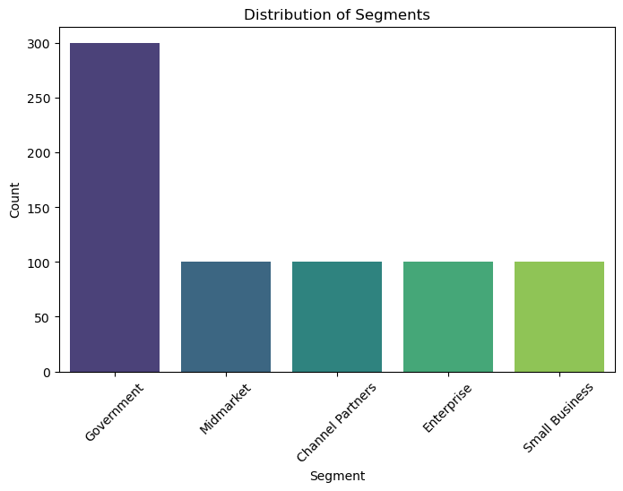
Understanding how many unique customers or product segments exist is important for targeted analysis. In our dataset, the Segment column represents different groups such as customer types or product lines.
By analyzing the dataset, we found that there are 5 unique segments:

- Government
- Midmarket
- Channel Partners
- Enterprise Small Business
These segments represent different target customer types or business models, and each one contributes differently to the total sales, profit, and revenue.
Insight:
This chart helps visualize which segment brings in the most revenue, allowing the business to make informed decisions about which customer group to focus on.

- The most common countries represented in the dataset
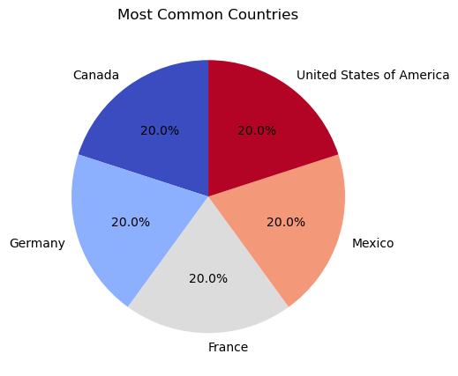

To identify which countries, have the most sales data entries and understand how frequently each country appears in the dataset. This helps us understand market reach and customer distribution geographically.
Interpretation:
- The United States appears as the most represented country in the dataset, followed by Germany, France, and Canada.
- These countries have the highest number of sales transactions, indicating strong customer or business presence in those regions.
- The distribution reflects where the company might already have established markets, warehouses, or strong logistics.
- Countries with fewer entries may indicate new or emerging markets that could be tapped into with more focused marketing or supply chain efforts.
Insight:
Understanding the geographic spread of your sales records is crucial. It allows you to:
- Focus marketing efforts on high-volume countries.
- Explore underrepresented markets for growth.
- Optimize shipping and logistics for high-frequency regions.

- The different product types
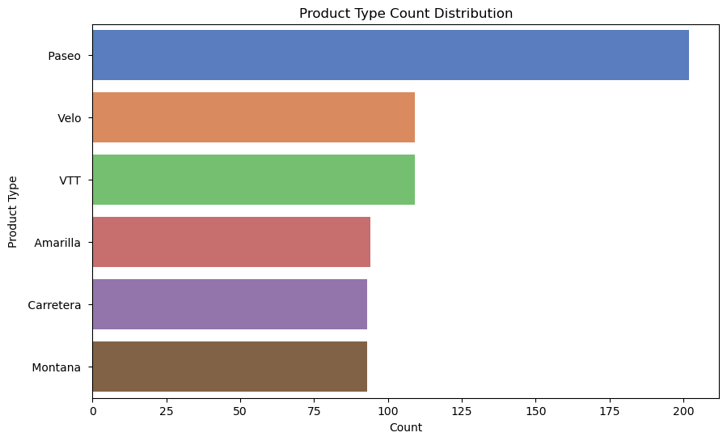
To explore the variety of products sold by the company and understand the sales distribution across product types. This helps in identifying the best-performing product lines and inventory focus.
Interpretation:
- Paseo, Velo and VTT are among the most frequently sold product types, suggesting high customer demand and popularity.
- Carretera and Amarilla are mid-range in terms of frequency, potentially niche products or targeted to specific customer segments.
- Montana appears less frequently, which may indicate a smaller target market or underperformance.
Insight:
- Products like Paseo, Velo and VTT could be further promoted, bundled, or upsold due to their popularity.
- Lower-selling products should be evaluated — either rebranded, repositioned, or discontinued if they're not profitable.
- Future inventory planning should factor in this distribution to reduce overstock or stockouts.

- The total revenue, Total cost & Total profit across all transactions
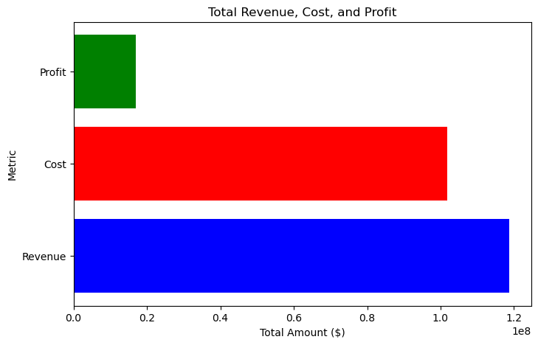
To gain a financial overview by comparing the total revenue, total cost, and total profit across the entire dataset. This helps us to understand the company’s overall performance and profitability.
- The Total Revenue is the highest value, crossing $110 million, indicating strong sales performance.
- The Total Cost is also significantly high, close to $100 million, which shows the company incurs large operational or production expenses.
- The Total Profit is positive but much smaller in comparison — around $17 million (estimated visually), which suggests a thin profit margin.
Interpretation:
- Although the business generates a high amount of revenue, costs are nearly as high, which limits profitability.
- The slim gap between revenue and cost indicates a need to optimize expenses or increase pricing for better profit margins.
- Despite that, being profitable is a positive sign, especially when managing a large-scale operation.
Insight:
This chart gives a quick snapshot of how the business is doing financially:
- High revenue indicates good product demand and sales.
- High-cost signals room for cost control.
- Modest profit shows the business is sustainable but not highly profitable yet.
This financial overview is essential for strategic planning, such as pricing adjustments, supplier negotiations, or focusing on high-margin products.

- Profit margins vary across different products
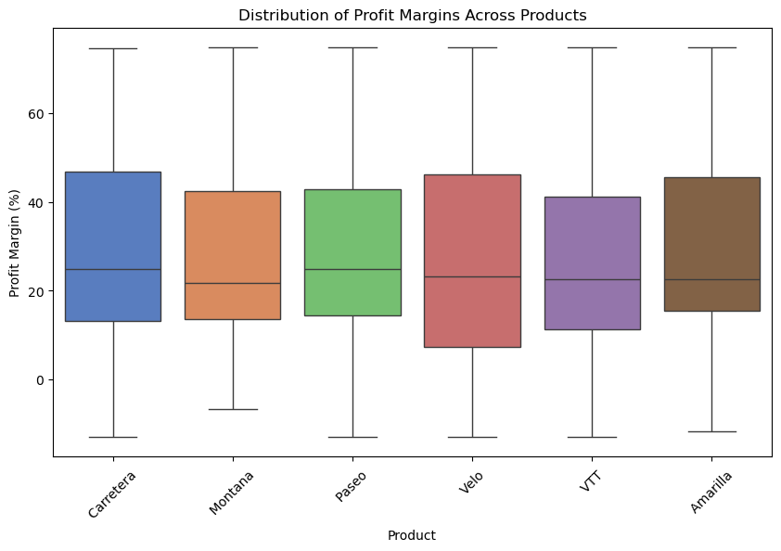
To analyze the variation in profit margins for each product line and identify which products offer better profitability and which ones show high variability or risk.
- All six products have similar overall distributions, but slight differences are noticeable in median values and spread.
- Carretera shows one of the highest median profit margins, suggesting it’s consistently profitable.
- Montana, Paseo, Velo, and VTT have similar median values (around 20–25%) but differ in variability.
- Amarilla has a relatively lower median, though its spread is wide, indicating inconsistent performance.
- All products show outliers and widespread, which means profit margins can vary a lot even within the same product range.
Interpretation:
- Products like Carretera and Velo seem more profitable on average and may be prioritized for marketing or bulk sales.
- Montana and VTT offer decent margins but may need a closer look at cost optimization.
- Amarilla shows a greater inconsistency in profit, which could be due to pricing issues, high-cost variability, or inconsistent demand.
Insight: This analysis helps with product-level strategic decisions:
- Focus on high-margin and stable products.
- Investigate why some products have a widespread — it might be due to discounts, regional pricing, or production costs.
- Use this insight to optimize product mix and pricing strategies for maximum profitability.

- Which segment generates the highest revenue and profit
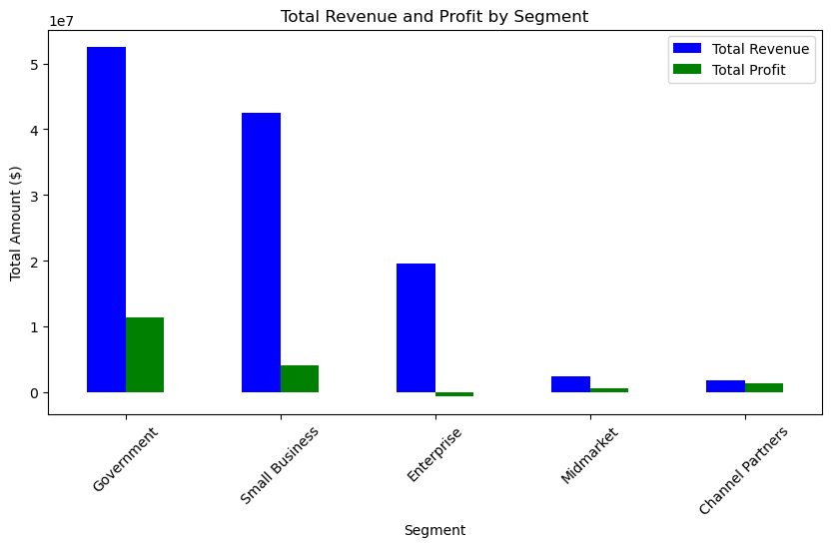
To identify which customer segment contributes the most to total revenue and profit, helping us to understand where the business is performing well and where there is potential for improvement.
- Government Segment:
  - Generates the highest revenue, exceeding $50 million.
  - It also yields the highest profit, over $10 million.
  - Indicates strong performance and profitability.
- Small Business Segment:
  - It comes second in both revenue (around $43 million) and profit.
  - Despite being smaller compared to government, it's a highly profitable market.
- Enterprise Segment:
  - Revenue is decent (around $20 million), but profit is very low—close to zero or even negative.
  - Suggests low margin deals or high operational costs.
- Midmarket Segment:
  - Generates small revenue and profit (each around $2–3 million).
  - Balanced but not a major contributor.
- Channel Partners:
  - Shows the lowest revenue (~$2 million) but interestingly generates a reasonable amount of profit compared to its revenue.
  - Indicates potential for cost-effective sales through partnerships.
Interpretation:
- The Government segment is clearly the top performer, offering both high revenue and healthy margins, making it a prime focus for business expansion.
- Small Business is a strong secondary target, with good balance between volume and profitability.
- Enterprise segment requires strategic review — although it brings in significant revenue, profit margins are alarmingly low.
- Channel Partners show potential for high ROI, and the business could explore scaling this segment with controlled investment.
Conclusion:
- Focus on expanding Government and Small Business segments.
- Reevaluate Enterprise pricing or cost structure to improve margins.
- Consider strengthening the Channel Partner network for efficient and profitable sales.

- Discounts impact profitability.
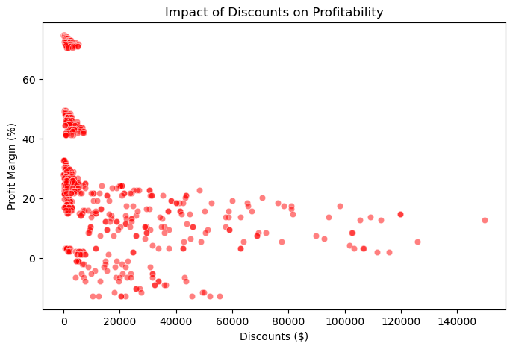
To examine the relationship between the amount of discount offered and the resulting profit margin (%), helping identify whether offering discounts leads to better or worse profitability.

A negative correlation is evident — as discounts increase, the profit margin tends to decrease.
The majority of high profit margins (40%–75%) are associated with low or zero discounts.
As discounts increase (especially beyond $10,000), profit margins mostly fall below 20%, with some even going into negative margins.
There are no high-margin transactions among the high-discount data points.

Interpretation:
- Discounts significantly reduce profitability.
- In many cases, giving large discounts results in little to no profit, and in some cases even losses (negative profit margin).
- The scatter of points also suggests that small discounts can still yield decent profits, but excessive discounting erodes margins heavily.

Insights:
- While discounts might be used to drive volume or customer acquisition, they hurt overall profitability.
- Businesses should explore alternative sales strategies, such as:
  - offering value-added services instead of direct discounts.
  - Tiered discount structures that maintain profitability.
  - Loyalty programs rather than flat-rate discounting.
- High discounts = Low profitability.
- Careful discount policies are essential to preserve profit margins.
- Businesses must balance discounting strategies with profitability goals, especially when aiming for sustainable growth.

- Trend of sales over time.
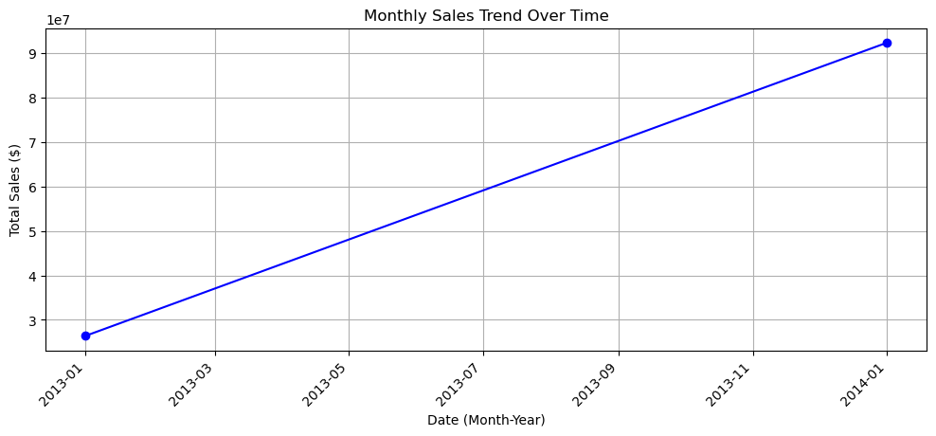
To analyze the trend in total sales ($) over time and determine whether there is growth, decline, or fluctuation in sales performance.
The graph is a line chart displaying:
- X-axis: Time (Month-Year format, from January 2013 to January 2014)
- Y-axis: Total Sales in dollars ($)
- Two data points are plotted — one in January 2013 and the other in January 2014.
- In January 2013, total sales were approximately $27 million.
- By January 2014, total sales had increased to approximately $92 million.
- The graph shows a consistent upward trend without dips or plateaus between the two points.
Interpretation:
- The company experienced substantial growth in total sales over the one-year period.
- The increase is nearly 3.5 times the initial sales value, indicating strong performance.
- Although the chart includes only two data points, the linear connection suggests a steady increase in sales, assuming no seasonal dips in-between.
The company likely implemented successful strategies during this period, such as:
- Expanding product offerings or markets.
- Effective marketing or promotional campaigns.
- Improved supply chain or customer reach.
This trend can be used to:
- Forecast future sales using linear or exponential models.
- Set sales targets for upcoming years.
- Evaluate the effectiveness of policies introduced in early 2013.
- Sales have grown dramatically over the year from January 2013 to January 2014.
- This upward trend suggests the business is on a positive trajectory, with strong market momentum.
- Further analysis with monthly data points could provide deeper insights into seasonal or promotional effects.

- Seasonal trends in sales and profits
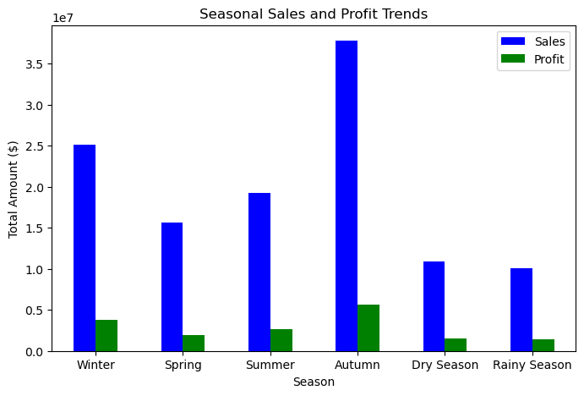
Autumn had the highest sales and profit.
Winter showed strong sales with moderate profit.
Spring and Summer had average performance.
Dry Season and Rainy Season recorded the lowest sales and profit.
Rainy Season was the least profitable.

Interpretation:
The grouped bar chart illustrates how total sales and profit vary across different seasons. Blue bars represent sales, and green bars represent profit. Each season shows distinct performance patterns, helping us understand business seasonality.
- Autumn stands out with the highest sales and profit, making it the peak season for business performance.
- Winter also performs well, with high sales and good profit margins.
- Spring and Summer fall into the moderate performance category.
- Dry Season and Rainy Season have the lowest sales and profit, indicating weak demand or higher operational challenges.
Insights:
- Peak Opportunity in Autumn:
  - This season offers the best ROI with maximum sales and profit.
  - Likely driven by festivals, holidays, or increased consumer spending behavior.
- Winter as a Growth Period:
  - Although not as strong as Autumn, Winter still contributes significantly to annual revenue.
  - Marketing strategies during this season can be optimized for even better returns.
- Need for Strategy in Off-Seasons:
  - Rainy Season and Dry Season show weak performance.
  - These periods may require focused promotions, cost control, or alternative product lines to maintain profitability.
- Balanced Approach in Mid-Seasons:
  - Spring and Summer are steady but not standout.
  - These seasons are good for experimenting with new campaigns or testing product launches.

- Month had the highest and lowest sales
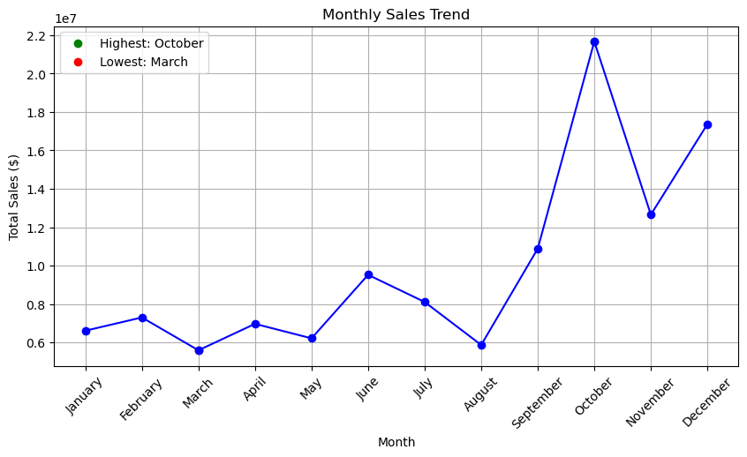
This chart shows the monthly sales trend throughout the year. The blue line connects the sales values, while green and red markers indicate the highest and lowest months respectively.
- Highest Sales: October
- Lowest Sales: March
Interpretation:
- The graph shows fluctuating monthly sales, with a noticeable peak in October and a dip in March.
- Sales start relatively low in the first quarter, rise steadily in mid-year, and then spike dramatically in the last quarter, especially in October.
- After October, there's a drop in November, but sales rise again in December.

Insights:
- October Surge:
  - October shows exceptional sales performance, possibly due to festive season, holiday shopping, or seasonal promotions.
  - This month should be leveraged with intense marketing campaigns, high inventory, and special offers.

- Weak March Sales:
  - March records the lowest sales, indicating either low demand, budget exhaustion, or end-of-financial-year slowdown.
  - Strategies such as discounts or targeted marketing can help uplift sales in this month.
- Strong Year-End:
  - November to December shows high sales, suggesting a strong year-end buying trend.
  - Capitalizing on this period can boost annual revenue significantly.
- Opportunities for Growth:
  - Analyze what drives the peak in October and December, and try to replicate similar conditions in weaker months.
  - Focus on months like March, May, and August to balance sales across the year.

- Different years compare in terms of revenue and profit
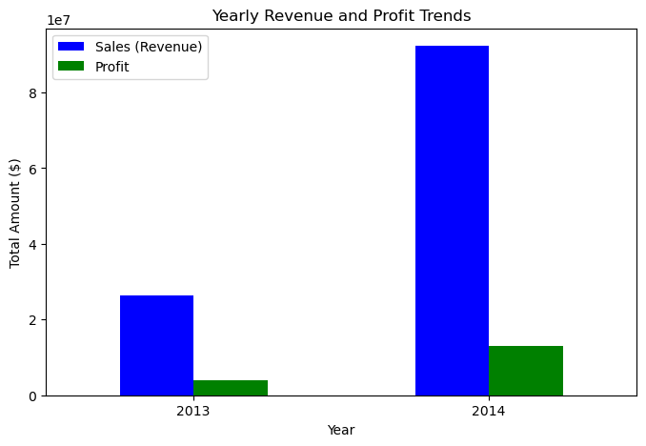
This graph compares total Sales (Revenue) and Profit between the years 2013 and 2014.
- Sales and profit in 2014 are significantly higher than in 2013.
- Sales (Revenue) increased from approximately $26 million in 2013 to nearly $89 million in 2014.
- Profit also grew from around $4 million to $13 million.

Interpretation:
- There is a sharp rise in both revenue and profit from 2013 to 2014.
- The business expanded operations or became more efficient in 2014, leading to higher earnings.
- The profit margin (profit as a percentage of sales) also appears to have improved slightly.
Insights:
- Strong Business Growth:
  - The massive jump in sales and profits indicates successful strategies, such as new product launches, better marketing, or expanded customer base.

- Scalability Confirmed:
  - The company showed it can scale profitably, as both revenue and profit increased proportionally.
- Investment Opportunity:
  - A consistent increase like this would attract investors and stakeholders as it reflects business stability and growth.
- Performance Benchmark:
  - 2014 performance can be used as a benchmark for setting future targets and business planning.

- Which country has the highest sales and profits
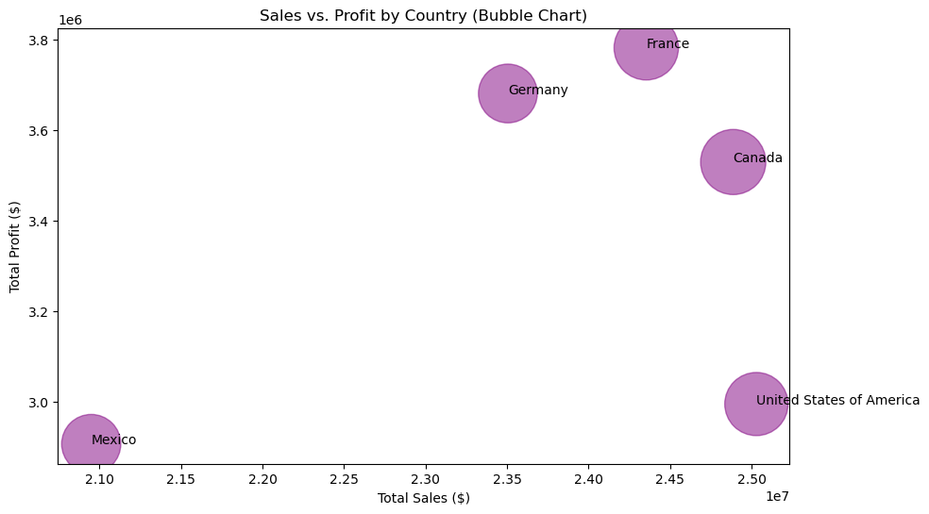

- France has the highest Total Profit (around $3.8 million).
- United States of America has the highest Total Sales (around $25 million), but its profit is relatively lower (around $3 million).
- Mexico has the lowest Total Sales ($21 million) and lowest Profit ($2.9 million).
- Germany and Canada are somewhere in the middle for both sales and profit.
Interpretation:
- The USA is leading in sales volume, but with moderate profit, which may indicate higher operational or production costs.
- France has slightly lower sales than the USA but achieves the highest profit, indicating higher profit margins.
- Mexico's lower sales and profit suggest either a smaller market size or lower customer purchasing power.
- Germany and Canada show a balanced performance in both sales and profit, indicating stable and consistent operations.

Insights
- France could be seen as a model market with high-profit margins. Studying its business strategy could help replicate success in other countries.
- For the USA, it's important to analyze cost structures to convert high sales into higher profit.
- In Mexico, further analysis is needed on market penetration or consumer behavior to boost both sales and profit.
- Canada and Germany are performing steadily – potential for growth with relatively lower risk.

- Sales and profits vary by region
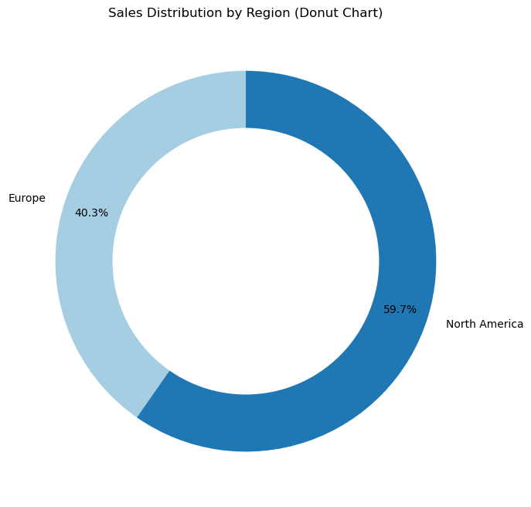
- North America accounts for 59.7% of total sales.
- Europe contributes 40.3% to total sales.
- North America has a significantly higher share of sales compared to Europe.
Interpretation:
- The company generates a majority of its revenue from the North American market.
- This indicates that North America is currently the dominant region in terms of customer base and market activity.
- Europe, while still a significant contributor, lags behind North America by nearly 20%.

Insights:
- North America is a stronghold market – it should continue to receive high strategic focus, especially in retaining market share and exploring further growth within mature segments.
- Europe holds potential – though its share is smaller, it still accounts for over 40% of sales. There may be opportunities to:
  - Expand product lines
  - Strengthen regional marketing
  - Explore unmet customer needs
- It would be valuable to compare profits from each region alongside sales. If Europe has higher profit margins (like we saw with France), then it may deserve greater investment despite lower sales.
- Consider diversifying market risk by exploring new or emerging markets, especially if sales in North America plateau over time.

- Which product category is the most profitable by region
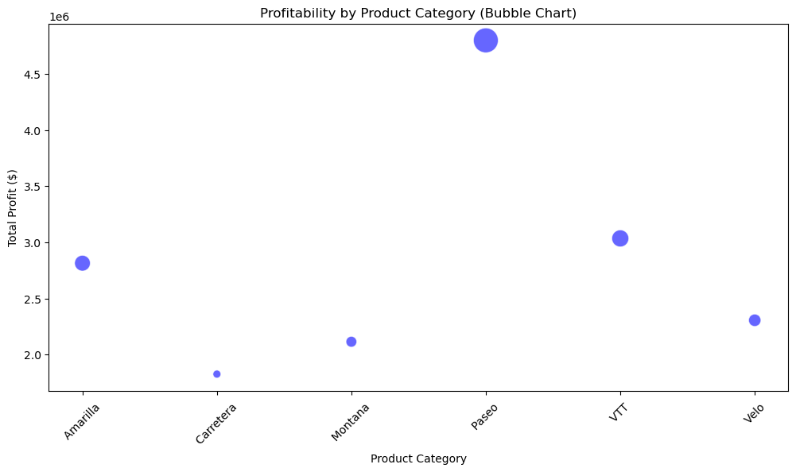
Profitability by Product Category
- Paseo is the most profitable product category, with the highest total profit (close to $4.8 million).
- Other notable product categories with decent profitability:
  - VTT (approx. $3 million)
  - Amarilla (approx. $2.8 million)
- Carretera has the lowest total profit among all categories.
- The size of the bubbles represents either volume sold or another impact factor (like units or sales), suggesting Paseo also has a significant market presence.
Interpretation:
- The Paseo category clearly leads in profitability, making it a key driver of business growth.
- Moderate profits from Amarilla and VTT indicate they are important supporting categories.
- Carretera and Montana, with smaller profits, may either have lower margins, lower sales volume, or higher costs.
Insights:
- Focus on Paseo:
  - Invest in marketing, promotion, and inventory for Paseo as it delivers the highest ROI.
  - Consider introducing new models or accessories in this category to expand profitability.
- Optimize Low-Performing Categories:
  - Investigate why Carretera and Montana underperform — is it due to low demand, poor pricing, or higher manufacturing costs?
  - Either reposition these products or consider discontinuing them if they don’t improve.
- Balance Strategy:
  - While Paseo dominates, over-reliance on one product category can be risky.
  - Diversify by improving profitability of mid-level performers like Amarilla and Velo.
- Regional Breakdown Needed:
  - This chart doesn’t directly show region-wise distribution. For deeper insight, combine this with a heatmap or grouped bar chart showing profitability by product and region.

- Are there certain products that perform better in specific countries?
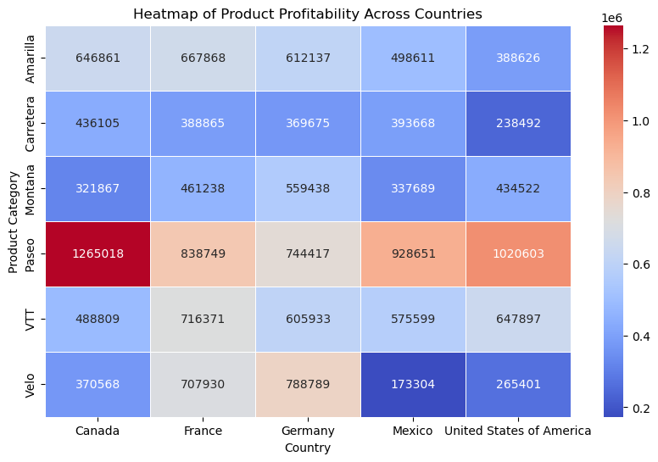
Based on the provided heatmap of product profitability across countries
Paseo is the most profitable product category across all countries, especially in:
  - Canada (1,265,018)
  - United States of America (1,020,603)
  - Mexico (928,651)
- Carretera and Montana consistently show lower profitability figures, particularly in the USA and Mexico.
- Velo performs well in Germany (788,789) and France (707,930), but poorly in Mexico (173,304) and the USA (265,401).
- Amarilla maintains relatively stable performance across all countries with moderate profitability (~600K range).
- VTT shows balanced profitability across the board, peaking in France (716,371) and showing lowest value in Germany (605,933).

Interpretation
- The Paseo category significantly outperforms others in North America, indicating strong product-market fit and potentially better marketing, distribution, or demand in that region.
- Velo appears to be favored more in Europe (France and Germany), which could point to regional preferences or better brand alignment.
- Products like Carretera and Montana underperform comparatively, possibly due to low demand, limited market reach, or pricing mismatch in most countries.
- The consistency of Amarilla across all countries may suggest it's a well-balanced product with stable but not outstanding performance.
Insights:
- Paseo is a market leader and could be a flagship product, particularly in North America.
- Product-country fit is evident, with clear regional preferences (e.g., Velo in Europe).
- There is a notable opportunity to investigate underperformance of certain products in specific regions (e.g., Velo in Mexico).
Recommendations:
- Double down on Paseo: Expand marketing efforts, promotions, and supply chain investments around Paseo in Canada, USA, and Mexico.
- Leverage Velo's success in Europe: Consider developing variants of Velo tailored to North American markets or increase promotional efforts to replicate European success.
- Re-evaluate Carretera and Montana: Conduct market research to identify causes of underperformance and explore repositioning or rebranding.
- Maintain Amarilla’s positioning: It can serve as a reliable, steady performer in all regions.

- Average sale price per product
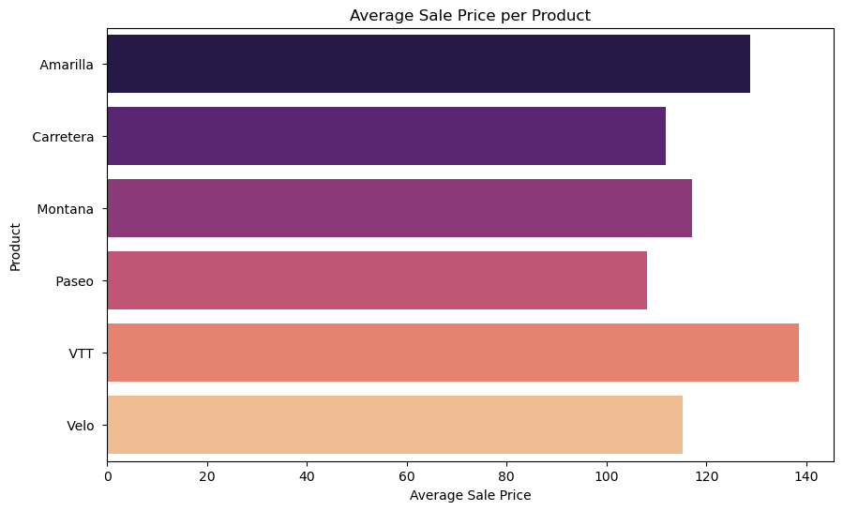
- VTT has the highest average sale price, closely followed by Velo.
- Paseo has a moderate price point, slightly below Montana and Amarilla.
- Carretera holds the lowest average sale price among all products.
- The price range across products varies approximately between ~100 to ~140 units.
Interpretation
- VTT and Velo are likely premium-positioned products, suggesting high perceived value, quality, or specialized features that justify their pricing.
- Amarilla and Montana fall into a mid-tier pricing zone, suitable for general customer segments looking for value.
- Carretera, with the lowest price, might be targeted at price-sensitive consumers or used as an entry-level offering.
- Paseo, despite its moderate price, shows high profitability (as seen in your earlier heatmap), implying strong demand or volume-based success.

Insights:
- High-priced products (VTT, Velo) could be driving higher per-unit margins, but may depend more on niche or loyal customer bases.
- Paseo's combination of a moderate price and high profitability is a strong indicator of mass appeal and volume-driven success.
- Carretera may need a pricing strategy review if it’s underperforming in profit despite being competitively priced.
Recommendations:
- Promote VTT and Velo as premium products — emphasize quality, exclusivity, or specialized use cases in marketing.
- Scale Paseo's reach — it’s a balanced product in terms of price and profitability; expanding its distribution or bundling it with accessories might boost sales further.
- Analyze Carretera's cost-to-profit ratio — if margins are too thin, consider slight price increases or cost reduction strategies.
- Experiment with dynamic pricing — test how slight price adjustments impact sales for mid-tier products like Amarilla and Montana across different regions.

- Different discount bands impact sales
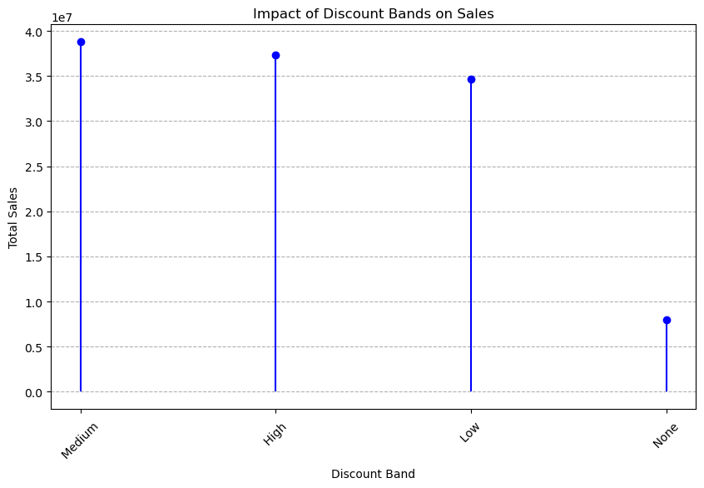
- Medium Discount Band leads to the highest total sales (~39 million).
- High Discount Band follows closely (~37 million).
- Low Discount Band results in slightly lower sales (~35 million).
- No Discount generates the lowest sales, significantly less (~7 million).
Interpretation
- The graph clearly indicates that offering discounts has a strong positive correlation with higher sales.
- Interestingly, a medium discount performs better than both low and high discounts, suggesting an optimal pricing sweet spot.
- No discount offers significantly underperform, implying that price incentives are crucial to drive customer purchases in this market.
- The slightly lower sales with high discounts compared to medium might hint at margin erosion or over-discounting, where customers buy more, but the revenue impact isn't proportionately better.

Insights:
- Discount strategies directly affect sales volumes — even small discounts (low band) make a notable difference compared to offering none.
- A medium discount strategy seems to strike the right balance between attracting customers and maintaining revenue.
- Offering too high a discount does not guarantee proportionally higher sales, possibly due to perceived product devaluation or saturation.
Recommendations:
- Focus on medium discount bands for most promotional strategies — this band appears to be most effective in maximizing sales.
- Avoid zero-discount policies, especially in competitive seasons or markets — they significantly underperform.
- Limit high discounts to special campaigns, clearance sales, or specific product lines to prevent margin losses.
- Perform a cost-benefit analysis for each discount tier by factoring in profit margins, customer acquisition cost, and long-term value.
- Segment customers by sensitivity and personalize discounting (e.g., loyalty-based, volume-based discounts).

- Correlation between discounts and units sold
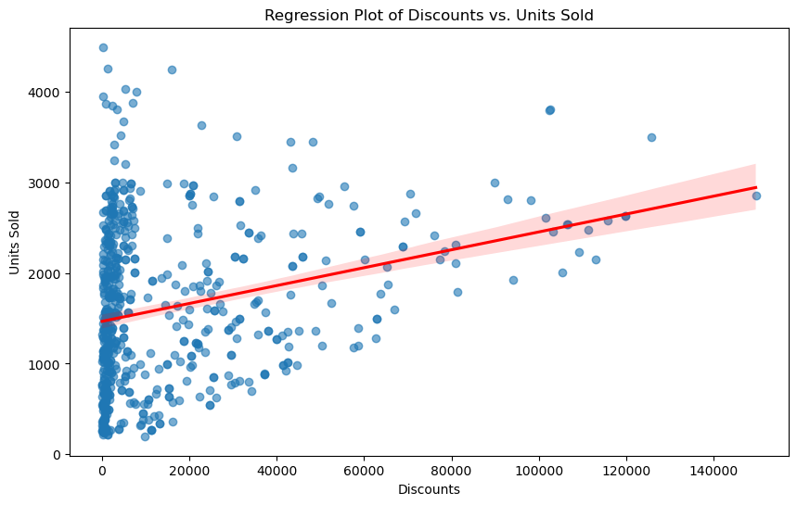
Observation
- The scatter plot shows a wide spread of data, especially at lower discount values.
- There's a positive linear trend as depicted by the red regression line.
- As discount value increases, the number of units sold tends to increase.
- Most data points are clustered near lower discount ranges, suggesting that lower discounts are more commonly applied.
- The regression line is moderately sloped, indicating a moderate correlation between discount and units sold.
Interpretation
- The positive slope of the regression line suggests that discounts are effective at boosting unit sales.
- The large spread of data points implies that other factors may also significantly impact sales volume (e.g., seasonality, product type, market demand).
- The shaded area around the regression line (confidence interval) widens as discounts increase, which suggests higher variability in units sold at higher discount levels.
- While discounts help drive more sales, the relationship isn’t perfectly linear — there is still a lot of variability, even when higher discounts are offered.
Insights:
- Discounting does work — higher discounts generally lead to higher unit sales.
- The correlation is not overly strong, meaning discounts alone won’t guarantee high sales.
- Sales at low or no discount levels can still be significant, possibly due to product popularity or market need.
Recommendations:
- Use discounts strategically — combine them with other factors like targeted marketing or seasonal timing to boost effectiveness.
- Avoid over-reliance on deep discounts — while they help in driving volume, they may also erode margins and lead to inconsistent results.
- Consider customer segmentation — use historical data to identify which segments respond best to discounts and personalize offers.
- Monitor diminishing returns — very high discounts might not lead to proportionate increases in sales and could harm brand perception.

- Average cost of goods sold (COGS) per product
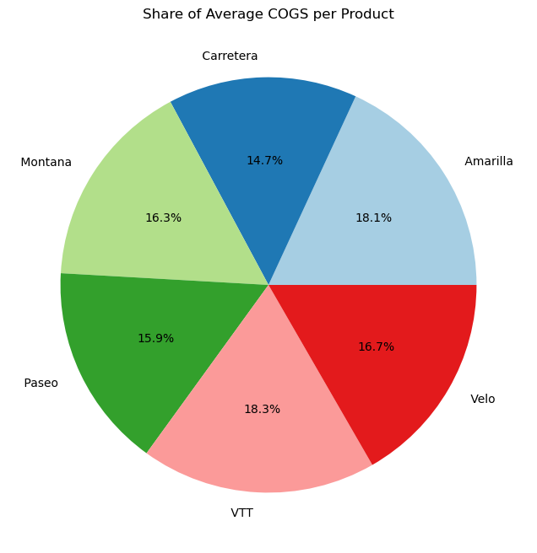
VTT has the highest share of COGS at 18.3%.
- Amarilla follows closely at 18.1%.
- Carretera has the lowest share of average COGS at 14.7%.
- The COGS distribution across products is fairly balanced, ranging between ~14.7% to ~18.3%, with no extreme outliers.
Interpretation
- Products like VTT and Amarilla are the most costly to produce on average, indicating that they either:
  - Use more expensive materials/components
  - Require more complex manufacturing
  - Or have higher handling/distribution costs
- Carretera incurs the lowest average production cost, possibly due to simpler design, economies of scale, or cheaper sourcing.

Insights:
- Products with higher COGS (like VTT and Amarilla) must be priced strategically to maintain healthy margins.
- Lower COGS products (e.g., Carretera) may present opportunities for:
  - Higher volume sales through competitive pricing
  - Better margin if priced smartly
- COGS distribution is relatively tight, suggesting a well-balanced product portfolio in terms of production cost.
Recommendations:
- Analyze profit margins across products — combine COGS with average sale price to identify high-margin vs. low-margin products.
- For high-COGS products:
  - Explore cost optimization opportunities.
  - Consider bundling or premium positioning.
- For low-COGS products:
  - Leverage price competitiveness to increase volume.
  - Test discount-driven promotions to drive growth while maintaining profitability.
- Keep monitoring COGS trends over time — especially if there are changes in supplier contracts, material costs, or production processes.

- Cost-to-sales vary across segments
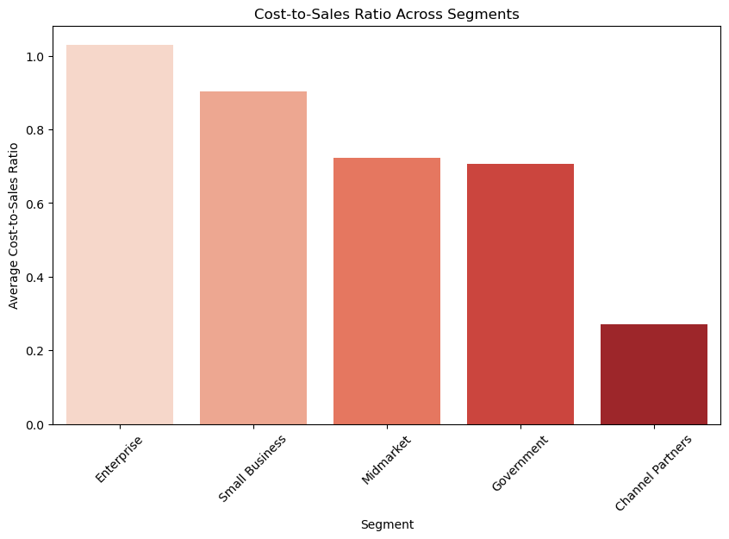
- Enterprise has the highest cost-to-sales ratio (>1.0), meaning its costs exceed sales on average — potentially operating at a loss.
- Small Business also has a high ratio, just under 1.0 — indicating minimal profitability.
- Midmarket and Government segments have moderate ratios (~0.7), implying a reasonable profit margin.
- Channel Partners show a significantly low ratio (~0.27), making it the most cost-efficient and potentially highly profitable segment.
Interpretation
- A higher cost-to-sales ratio means more cost incurred per unit of sales, resulting in lower profitability.
- Enterprise and Small Business segments likely have:
  - High servicing/support costs
  - Inefficient pricing strategies
  - Poor cost control
- Channel Partners, with their low ratio, may benefit from:
  - Bulk sales
  - Streamlined distribution
  - Lower customer acquisition or support costs
Insights:
- Enterprise segment may be operating at a net loss, warranting urgent attention.
- Channel Partners are the most profitable — this segment could be leveraged further.
- Government and Midmarket segments are balanced and can serve as stable revenue contributors.
Recommendations:
- Review pricing and cost structure for Enterprise and Small Business segments.
  - Reassess customer value delivery vs. servicing costs.
  - Consider optimizing operations, automating support, or adjusting pricing.
- Invest in Channel Partner programs:
  - Strengthen partnerships
  - Provide incentives or tools to increase volume
- Use Government and Midmarket as benchmarks for maintaining a healthy cost-to-sales balance.
- Conduct deeper segmentation analysis to identify specific causes behind high costs or low revenues in the Enterprise segment.

Business Insights & Recommendations
Key Sales & Profitability Insights
- Strong Seasonal Sales:
  - Sales peak in October, with Autumn being the most profitable season.
  - Winter also performs well, while Rainy and Dry seasons lag behind in both sales and profit.
- Top-Performing Products:
  - Paseo leads in total profit across all countries — ideal for continued investment and marketing.
  - Velo and VTT show strong performance in Europe, especially in Germany and France.
  - Carretera and Montana have the lowest profit margins — candidates for cost analysis or repositioning.
- Customer Segment Contribution:
  - The Government segment contributes over ₹50 million in revenue and ₹10 million in profit — the most profitable.
  - Small Business is the second-highest contributor with consistent margins.
  - Enterprise segment shows high revenue but almost zero or negative profit — needs urgent cost restructuring.
- Regional Profitability:
  - United States leads in revenue, but France achieves the highest profit, highlighting better cost efficiency.
  - Mexico shows the lowest performance in both sales and profit.
  - North America accounts for 60%+ of total sales, while Europe offers higher margins.
- Impact of Discounts:
  - Higher discounts reduce profit margins significantly.
  - Medium discount band performs best, generating the highest total sales.
  - Large discounts often lead to low or negative profits, highlighting the need for smarter discount strategies.
- Overall Business Growth:
  - Total sales grew from ₹27 million in Jan 2013 to ₹92 million in Jan 2014.
  - Total profit increased from ₹4 million to ₹13 million — a strong indicator of business scalability.

Cost Optimization Strategies
- Re-evaluate High Cost-to-Sales Segments:
  - The Enterprise segment has a cost-to-sales ratio greater than 1, indicating it's operating at a loss.
  - Conduct a detailed review of its operational costs, service models, and pricing structures.
  - Consider automation, bulk deals, or restructuring service packages for better cost efficiency.
- Promote Low-Cost, High-Margin Segments:
  - Channel Partners have the lowest cost-to-sales ratio (~0.27) and are highly profitable.
  - Expand partnership networks and provide tools or incentives to increase volume while keeping costs low.
- Product-Level Cost Efficiency:
  - VTT and Amarilla have the highest average COGS (~18%), requiring tighter cost control.
  - Explore cheaper raw materials, improved logistics, or contract renegotiation for these product lines.
  - Carretera, with the lowest COGS (~14.7%), could be priced or marketed more aggressively for volume-based profit.
- Optimize Discount Strategy:
  - High discounts lead to low or negative profits.
  - Implement tiered discounting, loyalty programs, or value-added offers instead of flat price reductions.
  - Focus on medium discount bands, which offer the best balance between volume and profitability.
- Regional Cost Management:
  - France shows high profitability even with lower sales — review and adopt its cost models in other regions.
  - In contrast, USA and Mexico show high sales but low profits — analyze distribution, labor, and logistic costs regionally.
- Inventory & Supply Chain Efficiency:
  - Focus on high-performing products like Paseo to streamline inventory.
  - Reduce stocking of underperforming SKUs to minimize warehousing and handling costs.
- Regular COGS Monitoring:
  - Track changes in Cost of Goods Sold (COGS) over time.
  - Set automated alerts for any sudden rise in product-level cost to enable timely corrective actions.
Suggestions for Improving Revenue
- Leverage Peak Sales Seasons:
  - Focus marketing and inventory around Autumn and Winter, especially October and December, which show peak revenue.
  - Launch festive-season campaigns and bundle offers to capitalize on consumer spending spikes.
- Expand High-Performing Segments:
  - Invest more in Government and Small Business segments, which are consistently profitable.
  - Create customized pricing plans and service bundles for these segments to increase deal size.
- Scale Profitable Product Lines:
  - Paseo is the most profitable product — expand its availability, variants, and bundling options.
  - Promote Velo and VTT in regions like France and Germany, where demand and margins are both high.
- Geographical Revenue Focus:
  - Strengthen presence in USA and France, where sales and/or profits are highest.
  - Identify underperforming markets like Mexico and launch localized campaigns or pricing strategies.
- Optimize Pricing Strategy:
  - Introduce dynamic pricing models based on season, product category, and customer type.
  - Use data to identify optimal price points that balance volume and margin.
- Improve Customer Retention:
  - Analyze buying patterns and offer personalized promotions, loyalty programs, or subscriptions to frequent buyers.
  - Retaining a customer is cheaper than acquiring a new one — focus on lifetime value.
- Refine Discount Strategy:
  - Offer medium-level discounts, which drive the most revenue without eroding profit.
  - Avoid over-discounting, especially in high-margin product lines.
- Launch in Emerging Markets:
  - Explore countries or regions with low current sales but market potential.
  - Run pilot campaigns with limited inventory to test demand.
- Upselling & Cross-Selling:
  - Recommend related products during checkout or follow-up marketing.
  - Bundle complementary items to increase average order value (AOV).
- Data-Driven Sales Forecasting:
- Use historical data trends to predict future demand.
- Prepare inventory, marketing, and staffing accordingly to meet forecasted revenue targets.

Customer Retention & Growth Strategies
- Introduce Loyalty Programs:
  - Reward repeat customers with points, exclusive offers, or early access to new products.
  - Encourages repeat purchases and strengthens long-term relationships.
- Segment-Based Personalization:
  - Use sales data to identify customer segments like Government, Small Business, and Channel Partners.
  - Send targeted communication and offers based on purchase behavior and segment profitability.
- Offer Subscription or Reorder Services:
  - For frequently purchased products, provide auto-replenishment or subscription models.
  - Increases customer convenience and ensures recurring revenue.
- Improve Post-Sales Engagement:
  - Send thank-you emails, feedback surveys, and product usage tips.
  - Active post-sale communication enhances customer satisfaction and trust.
- Monitor Customer Churn:
  - Identify inactive customers or those who stopped ordering.
  - Reach out with reactivation campaigns or special offers to win them back.
- Invest in Customer Service:
  - Quick support and resolution drive higher retention.
  - Train service teams to be responsive and solution-oriented, especially for enterprise and midmarket clients.
- Cross-Sell and Upsell Opportunities:
  - Recommend related or higher-tier products based on past purchases.
  - Increase Average Order Value (AOV) and maximize revenue per customer.
- Leverage Customer Feedback:
  - Collect and analyze feedback to improve product quality and customer experience.
  - Build a reputation of being customer-focused, which increases loyalty.
- Build Community & Brand Connection:
  - Engage customers through social media, user groups, or events.
  - Emotional brand connection often leads to stronger loyalty than discounts alone.
- Measure Customer Lifetime Value (CLV):
- Focus on long-term value rather than just short-term revenue.
- Use CLV to prioritize marketing and retention investments in high-value customer groups.

Summary & Conclusion
Final Key Takeaways
- Paseo is the most profitable product across all countries, especially in North America — it should be the centerpiece of growth strategies.
- October and Autumn are peak sales periods, indicating strong seasonality in customer purchasing behavior — campaigns should align accordingly.
- Government and Small Business segments are the highest revenue and profit generators — they deserve focused attention and customized solutions.
- France delivers the highest profit margins, despite lower sales volume — a model for cost-effective operations.
- High discounts reduce profitability significantly, while medium discounts maximize sales — highlighting the need for a balanced pricing strategy.
- Enterprise segment shows high costs with low profit, suggesting an urgent need for cost restructuring or better deal pricing.
- Velo and VTT perform best in Europe, while Montana and Carretera underperform, signaling opportunities for product repositioning.
- North America leads in sales volume, but Europe has higher profit margins — geographic strategy should balance both.
- Revenue and profit nearly tripled from 2013 to 2014, indicating strong business scalability and market acceptance.
- Customer behavior is highly sensitive to pricing and seasonality, emphasizing the importance of dynamic pricing and targeted marketing.
Future Scope of Analysis
- Advanced Predictive Modeling:
  - Use historical sales data to build forecasting models (e.g., ARIMA, Prophet) for predicting future sales and demand trends.
  - Helps in proactive inventory management and sales planning.
- Customer Lifetime Value (CLV) Analysis:
  - Analyze customer behavior to estimate the long-term value of different customer segments.
  - Useful for budgeting marketing spend and prioritizing retention efforts.
- Market Basket Analysis:
  - Implement association rule mining (like Apriori or FP-Growth) to discover product purchase combinations.
  - Helps in cross-selling, bundling, and personalized product recommendations.
- Churn Prediction:
  - Use machine learning models to identify customers likely to stop buying.
  - Enables timely intervention through personalized offers or engagement.
- Regional Pricing Optimization:
  - Analyze price sensitivity across countries or regions to fine-tune pricing for maximum profit without losing volume.
- Real-Time Dashboard Integration:
  - Deploy interactive dashboards (using Power BI or Tableau) for stakeholders to monitor sales, profit, and customer metrics in real-time.
- Product Development Insights:
  - Use feedback and sales data to inform new product designs or improvements in existing offerings, especially in underperforming categories like Carretera and Montana.
- Integration with Marketing Data:
  - Combine sales data with campaign performance metrics to assess ROI of marketing efforts.
- Supply Chain & Logistics Analysis:
  - Analyze delivery timelines, cost efficiency, and warehousing to improve operational performance.
- Competitive Benchmarking:
  - Compare internal performance metrics with market standards or competitors (if data available) to identify gaps and opportunities.

GitHub Link & References
GitHub Repository Link:
🔗 https://github.com/Haimik-Solanki/Financial-Sales-EDA
The repository contains:
- Python Notebook (.ipynb) for complete EDA
- Cleaned dataset used in analysis
- Final PDF report
- README with project overview and instructions

References:
- Python Libraries:
  - Pandas Documentation
  - Matplotlib Documentation
  - Seaborn Documentation
  - NumPy Documentation
- EDA Process Guide:
  - Towards Data Science articles on EDA best practices
  - Kaggle notebooks and datasets used for learning
- Academic/Institutional Support:
  - Fly The Nest Institute – for guidance and mentorship
  - Project Supervisor: Mr. Chintan Patel

